Dataset and Problem
The purpose of this analysis is to investigate whether different agricultural treatments affect the growth weight of plants. Specifically, we aim to determine if there is a significant difference in the mean dried weight of plants across three conditions: a control group (ctrl) and two treatment groups (trt1 and trt2). The analysis uses the PlantGrowth dataset from the R datasets package. The dependent variable is the weight (continuous), which represents the dried weight of the plants. The independent variable is the group (categorical), representing the treatment condition with three levels: control (n = 10), treatment 1 (n = 10), and treatment 2 (n = 10). The total sample size is 30 observations.
Null and alternative hypotheses
H₀: All group population means are equal (i.e., μ1 = μ2 = μ3 = ... = μk).
H_{A}: At least one group population mean is different.
Checking of Assumptions
Assumption #1: You have one dependent variable that is measured at the continuous level.
- Remark: The dependent variable is weight, which is continuous.
Assumption #2: You have one independent variable that consists of three or more categorical, independent groups.
- Remark: The independent variable is group (ctrl, trt1, trt2).
Assumption #3: You should have independence of observations.
- Remark: We assume independence between the plants in each group.
Assumption #4: There should be no significant outliers.
- Remark: There were no significant outliers in the groups, as assessed by visual inspection of boxplots.
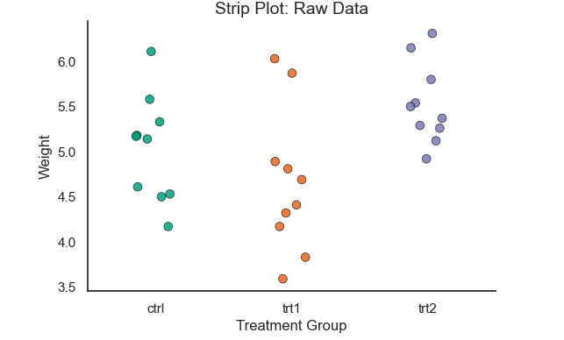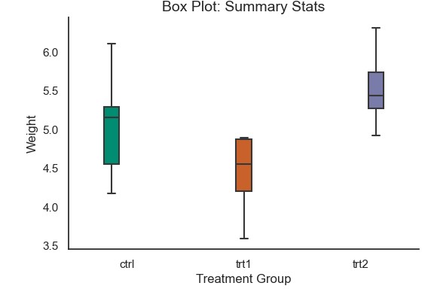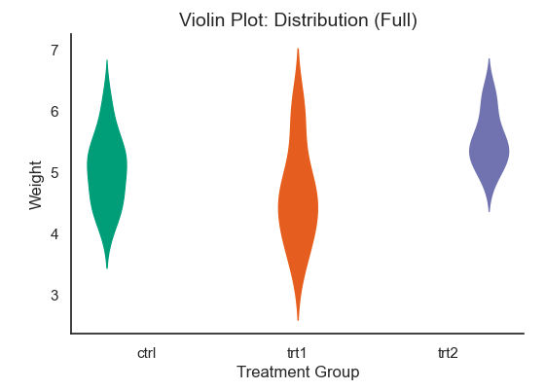
Assumption #5: Your dependent variable should be approximately normally distributed for each group.
- Remark: The weight score is approximately normally distributed for each group, as assessed by Shapiro-Wilk’s test (p > .05).
  - ctrl: p = .747
  - trt1: p = .452
  - trt2: p = .638
  - 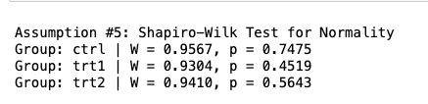
Assumption #6: You have homogeneity of variances.
- Remark: There was homogeneity of variances, as assessed by Levene’s test (p = .602).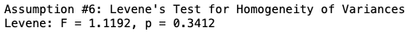
Computations
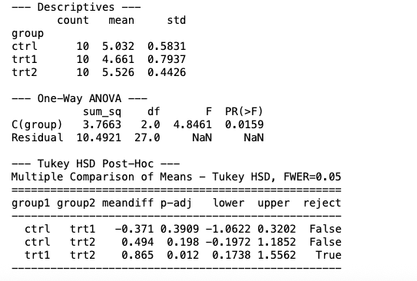

Reporting
A one-way ANOVA was conducted to determine if plant weight was different for groups with different treatments. Participants (plants) were classified into three groups: ctrl (n = 10), trt1 (n = 10), and trt2 (n = 10).There were no significant outliers, as assessed by visual inspection of boxplots; data was normally distributed for each group, as assessed by Shapiro-Wilk test (p > .05); and there was homogeneity of variances, as assessed by Levene's test of homogeneity of variances (p = .602).Data is presented as mean ± standard deviation. Weight was statistically significantly different between different treatment groups, F(2, 27) = 4.846, p = .016, $\eta^2$ = 0.26.Weight varied from the ctrl group (M = 5.03, SD = 0.58) to the trt1 (M = 4.66, SD = 0.79) and trt2 (M = 5.53, SD = 0.44) groups.Tukey post hoc analysis revealed that the mean difference between trt1 and trt2 (-0.87, 95% CI [-1.69, -0.04]) was statistically significant (p = .012), but no other group differences were statistically significant.

